Green Printing

Do you really need to print?
It is possible to save a document as a PDF from the Print dialogue box. This can often be emailed to an E-book reader such as a kindle. If doing so remember to make sure the text is large enough to read on your device.

Who are you printing the document for?
If you are printing the document to have a hard copy to reference or to annotate, do you need to print the document full size? An option exists to print 2 or more pages on a single sheet of A4. Combined with double sided printing this can reduce the amount of paper needed for a 100 Page document down to just 25 sheets. Not only is this good for saving paper but it’s also easier to carry.

Save your settings!
Rather than relying on remembering the correct setting every time you go print, save a couple of different sets of print options. You can then select the set you want to use depending on what you are printing the document for. A couple of suggestions for pre-sets might be.
- E-Reader (A5 Paper Size of E-Reader, black & white to reduce file Size)
- Draft (Two Pages per Side, Double sided, A4, black & white, low ink)
- Double Sided (Double sided, Colour)
- Single Sided (Single sided, Colour)

Where are all these options?
To create a simple user interface the printing options on OSX are generally hidden away.
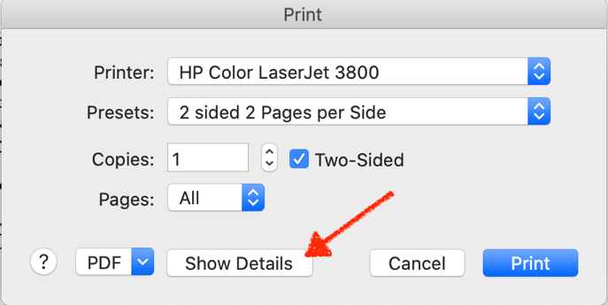
Once expanded there are many more options available. Most are self-explanatory but some are not.
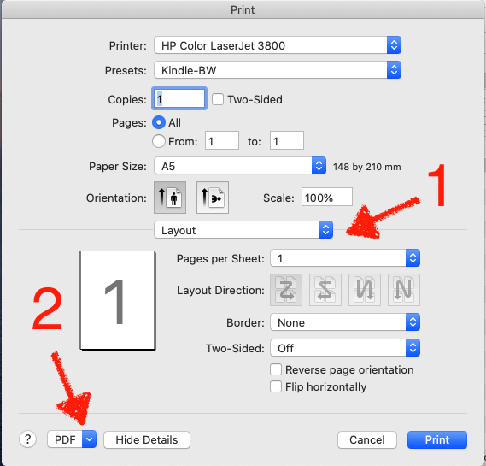
1 – (Layout)
This hides a lot more options including Colour options and print quality.
2 – (PDF)
Allows you to preview the output before printing as well as saving as a PDF document.
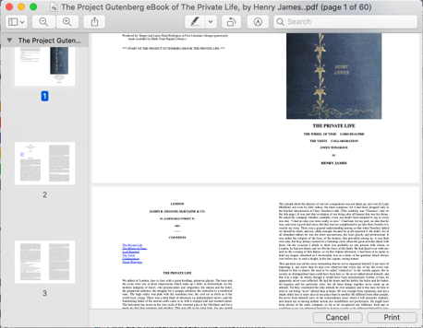
Once you are happy with a set of print options you can save them as a “Preset”.
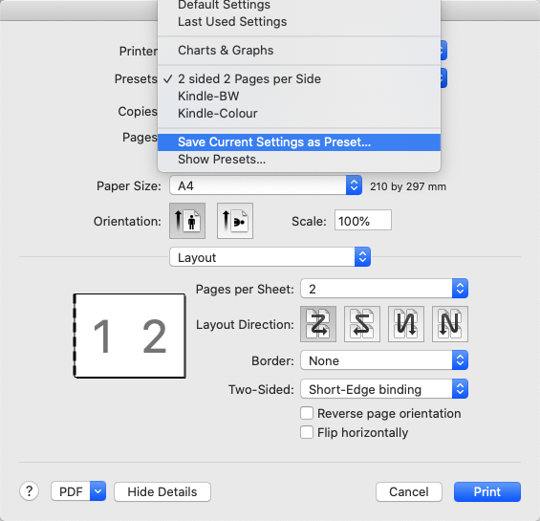
Note you can also select “Show Presets” from which you can review the settings of all of your saved presets.
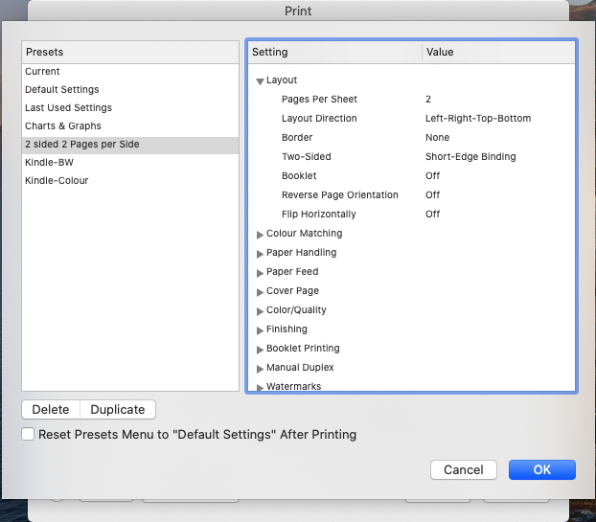

Document History
Date | Who | Change
27 Jan 2021 | Antony Nelson | Initial draft
27 Jan 2021 | Andrew Raine | Formatting

